**Course Syllabus Part I**

**CIS 102 – Getting Started with Video Game Development**

**3 Credit Hours**

**Course Description**

This course introduces video game development to video game fans with no programming experience. Through cheap, easy to learn tools, we will tackle the essence of video game development from prototype to post mortem. By the end of this course, you will have a game you, your friends, and your family can play.

**Course Prerequisites:** None

**Course Objectives**

By the end of this course, you will be able to:

1. Identify the tools of game development.
2. Explain the methods of video game development.
3. Develop game prototypes for further development.
4. Provide critical feedback for game prototypes.
5. Apply feedback to game prototypes.
6. Document design decisions within design documents and computer code.

**Grading Scale**

|  |  |  |  |
| --- | --- | --- | --- |
| 93 – 100% = A | 87 – 89% = B+ | 77 – 79% = C+ | 67 – 69% = D+ |
| 90 – 92% = A- | 83 – 86% = B | 73 – 76% = C | 63 – 66% = D |
|  | 80 – 82% = B- | 70 – 72% = C- | 60 – 62% = D- |
|  |  |  | 0 – 59% = F |

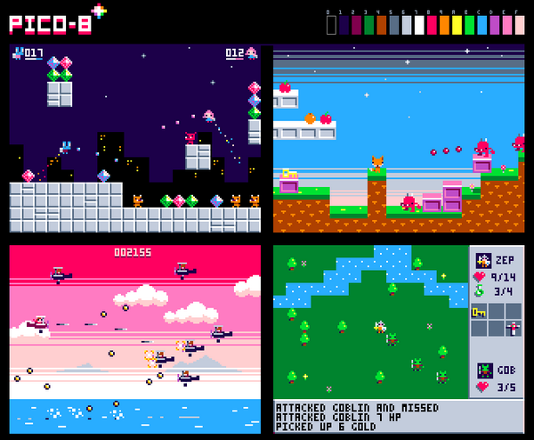 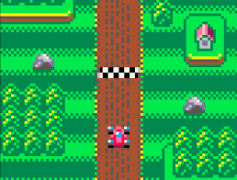

**Topic Outline**

1. Getting Situated
   1. What are games?
   2. How are video games made?
   3. Fantasy Consoles
   4. Getting to know PICO-8
   5. Getting started with programming
2. Production – Week 1-2
   1. Functions
   2. Variables
   3. Design: Central Loops
3. Production – Week 3-4
   1. If-Statements
   2. Collision Detection
   3. Design: Prototyping
4. Production – Week 5-6
   1. Sound Effects
   2. Player Input
   3. Design: Getting off the beaten path
5. Production – Week 7-8
   1. Debugging
   2. Juicing in PICO-8
   3. Design: Juicing
6. Production – Week 9-10
   1. Putting it all together.
   2. Design: Feedback and Criticism in Game Design
7. Distribution – Final Weeks
   1. Deploy
   2. Critique
   3. Post Mortem
   4. What next?



**Course Syllabus Part II**

**CIS 102 – Getting Started with Video Game Development**

**3 Credit Hours**

# Course Resources

## Course Text:

There is no text for this course. All materials are located at a GitHub Repository:

<https://github.com/nicklalone/CIS---102---Getting-Started-with-Video-Game-Development>

## Required Resources:

You will need to purchase a copy of PICO-8. The product is $14.99 and can be obtained:

<https://www.lexaloffle.com/pico-8.php#getpico8>

## Supplemental Resources:

While not required, the PICO-8 FanZine has a ton of great resources from all sorts of game makers. There are copies of the PDF on the Github Repository. You can also find it in print at:

<https://sectordub.itch.io/pico-8-fanzine-1>

## Course Schedule

|  |  |  |  |  |  |
| --- | --- | --- | --- | --- | --- |
| Week | Topic | Critique | Milestones | HW # | Project Deadline |
| 1 | Getting Started | 1 |  | 1 |  |
| 2 | Functions and IF | 2 |  | 2 |  |
| 3 | Controller Input | 3 |  | 3 |  |
| 4 | Stuff Hitting Things | 4 | Mid-Point Check-in | 4 |  |
| 5 | Game States and You | 5 |  | 5 |  |
| 6 | Show and Tell – Midterm |  |  |  | Midterm Due |
| 7 | Audio | 6 |  | 6 |  |
| 8 | AI and Enemies | 7 |  | 7 |  |
| 9 | Levels or Game States II | 8 |  | 8 |  |
| 10 | Tokens and Compression | 9 | Final- Check-in | 9 |  |
| 11 | Juicing and Game Feel | 10 |  | 10 |  |
| 12 | Final Project Work |  |  |  | Last day of class |

# Course Activities

From the schedule above, you can see that each week you’ll be doing a little bit of writing, a little bit of playing, and a little bit of programming. You can find each of the assignments on Cyberactive OR on the Github Repository. The week is almost always split between 3 different activities:

1. Critiques
2. Homework
3. Project Work (Midpoint or Final)

Each activity is generally concerned with either getting you into programming, getting you in to exploring what can be done with programming, and thinking about how your own preferences and ideas about games can not only be useful, but are necessary for great design.

1. **Critique**

PICO-8 is a fantasy console that is open to the public and hosts an unimaginable number of games. One of the ways you can learn more about programming and game design is to *find, play, and talk about* other games. Each week, you will find a game to play that interests you and make a post in the required discussion board. That post will have the following structure.

* *Name of the game and Link*
* *What made you play it?*   
  (2 sentences that go beyond – “It looked neat.”)
* *What did you like about it OR what was useful about it?*(2 sentences that go beyond – “It was fun.” Or “It was interested.”)
* *What didn’t you like about it?*  
  (2 sentences that go beyond – “It was fun.” Or “It wasn’t fun.” OR “It wasn’t interesting.”)

In addition to posting your own critiques, you will find 2 other posts in the discussion board and respond to them. These responses should be about a paragraph in length. The word substantive gets thrown around a lot but what does that mean? Your responses should be enough to provoke conversation. We all have opinions about games and those opinions will influence the games we make. Writing “substantive” posts will not only help those you’re writing for but yourself as well.

1. **Homework**

There are 11 of these with exceptions coming in the form of Midterm Week as well as the Final Week.

These will be turned in via CyberActive and are all located on the GitHub Repository as well as the Assignment links themselves. Generally, these will relate to that week’s content and ask you to write a PICO-8 Program or adjust a PICO-8 Program as needed.

1. **Project Work**

There are 2 projects in this course – Your Midterm (which will be you providing what is asked for) and your Final Project (which will be what you decide to make). The breakdown of these projects are as follows:

* 1. **The Midterm Project**

This project will be an application of each week’s content up until midterm week. How you meet all of these concepts is up to you but for the most part, the parameters are known but the way those parameters are met is up to you. For those of you who are worried about the difficulty of the task, know that each week leading up to the midterm results in a project you can submit with a few modifications. For more on the midterm project, please find the handout: “CIS 102 – Midterm Handout.pdf.”

The parameters that you’re going to meet include:

* Variables / Objects
* Player Input
* Object Collisions
* Game States
  1. **The Final Project**

This project is entirely on you though there is a checklist I will be using to grade your assignment much like the Midterm Project. Up until this point, you have been confined to games that do not have any sound. Additionally, you’ve been shown games that resemble Pong, Breakout, or something like them. However, this is just an introduction to different tools that are used to make games. With the knowledge you have of game states and the content after the midterm, you will have all the tools you need to make a game of…almost any type.

The Final Project description and additional parameters are located inside the handout called, “CIS 102 – Final Project Handout.pdf.”

# Grade Breakdown/Criteria

You will find the breakdown of the point system for class below. The total points are 1000 and if you want to know your final grade, simply divide your total points by 10.

|  |  |  |  |  |
| --- | --- | --- | --- | --- |
| **Activity** | **Points Per** | **How Many?** | **Total Points** | **% of Final** |
| Critique | 25 | 10 | 250 | 25 |
| Homework | 35 | 10 | 350 | 35 |
| Midterm | 120 + 30 | 1 + Check-in | 150 | 15 |
| Final Project | 200 + 50 | 1 + Check-in | 250 | 25 |
|  |  |  |  |  |
| Total |  |  | 1000 | 100 |

# On Video Games, Learning to Make Games, and “Real Life”

You will not be learning about what makes a game good or great in this class; however, you will be playing at least 10 different games in an effort to think about what you’re learning each week. Those games will vary wildly in quality but each game you play (regardless of quality) should challenge you to think about games in differently. That word, “differently” is important. With something that is attached to life, to identity, difference is often met with frustration, even rejection. Games are an essential aspect of our everyday life because games let us see everyday life in ways that we haven’t thought of before. The difference and diversity of games and gaming reflects this concept. If you want to *make* games, the most uncomfortable part of that task is to learn to think about everyday life in ways that both highlight AND hide it.

# Late Work

Every day your assignment is not turned in results in a 10-point loss for that assignment until that assignment reaches 0. If the assignment reaches 0, your next assignment begins to lose points. To avoid this stiff penalty, make sure to contact the professor to make arrangements. Late work is not accepted unless arrangements are made with the instructor for special circumstances.

# Participation

Students are expected to login often and contribute to the class on a regular basis, including posting to the discussion board, submitting assignments, and participating in group activities as required. If you have specific participation requirements related to your educational funding or student status, you are expected to monitor your own participation to ensure you are in compliance with those requirements.

# Expectations for Students

* Students should expect to spend approximately 5-10 hours per week to complete the activities and assignments in this course.
* Students will log in as often as needed to complete their assignments and progress through the course.
* Students will treat their classmates and the instructor with respect and courtesy.
* Students are responsible for keeping current with the reading assignments and coming to class prepared to discuss the work assigned.
* Students are responsible for knowing what assignments are due and when.
* Students will submit only their own work and will not commit plagiarism or other acts of academic dishonesty.
* Students will contact the instructor as soon as personal problems arise that may affect the student’s ability to complete assignments on time.

# Expectations for Faculty

* The instructor will treat all students with respect and courtesy.
* The instructor will make grading criteria clear and follow the criteria scrupulously in evaluating student work.
* The instructor will provide feedback about student work within 6 days of due dates (or 24 hours prior to the next due date)—feedback that helps the student learn and improve.
* The instructor will respond to all student messages within 48 hours.